STRESS ANALYSIS IN WING AND FUSELAGE:
Posted on April 23, 2014
V-n Diagram
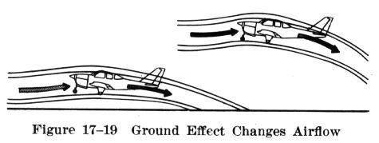
The flight operating strength of an airplane is presented on a graph whose horizontal scale {should be vertical scale -Ed.} is based on load factor (Fig. 17-19) {should be Fig. 17-50 – Ed.}. The diagram is called a V/g diagram – velocity versus “g” loads or load factor. Each airplane has its own V/g diagram which is valid at a certain weight and altitude.
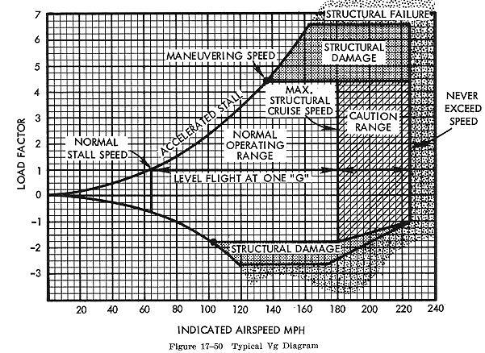
The lines of maximum lift capability (curved lines) are the first items of importance on the V/g diagram. The subject airplane in the illustration is capable of developing no more than one positive “g” at 62 mph, the wing level stall speed of the airplane. Since the maximum load factor varies with the square of the airspeed, the maximum positive lift capability of this airplane is 2 “g” at 92 mph, 3 “g” at 112 mph, 4.4 “g” at 137 mph etc. Any load factor above this line is unavailable aerodynamically; i.e., the subject airplane cannot fly above the line of maximum lift capability (it will stall). Essentially the same situation exists for negative lift flight with the exception that the speed necessary to produce a given negative load factor is higher than that to produce the same positive load factor.
If the subject airplane is flown at a positive load factor greater than the positive limit load factor of 4.4, structural damage will be possible. When the airplane is operated in this region, objectionable permanent deformation of the primary structure may take place and a high rate of fatigue damage is incurred. Operation above the limit load factor must be avoided in normal operation.
There are two other points of importance on the V/g diagram. Point A is the intersection of the positive limit load factor and the line of maximum positive lift capability. The airspeed at this point is the minimum airspeed at which the limit load can be developed aerodynamically. Any airspeed greater than point A provides a positive lift capability sufficient to damage the airplane; any airspeed less than point A does NOT provide positive lift capability sufficient to cause damage from excessive flight loads. The usual term given to the speed at point A is the “maneuvering speed,” since consideration of subsonic aerodynamics would predict minimum usable turn radius to occur at this condition. The maneuver speed is a valuable reference point since an airplane operating below this point cannot produce a damaging positive flight load. Any combination of maneuver and gust cannot create damage due to excess airload when the airplane is below the maneuver speed.
Point B is the intersection of the negative limit load factor and line of maximum negative lift capability. Any airspeed greater than point B provides a negative lift capability sufficient to damage the airplane; any airspeed less than point B does not provide negative lift capability sufficient to damage the airplane from excessive flight loads.
The limit airspeed (or redline speed) is a design reference point for the airplane – the subject airplane is limited to 225 mph. If flight is attempted beyond the limit airspeed structural damage or structural failure may result from a variety of phenomena.
Thus, the airplane in flight is limited to a regime of airspeeds and g’s which do not exceed the limit (or redline) speed, do not exceed the limit load factor, and cannot exceed the maximum lift capability. The airplane must be operated within this “envelope” to prevent structural damage and ensure that the anticipated service lift of the airplane is obtained. The pilot must appreciate the V/g diagram as describing the allowable combination of airspeeds and load factors for safe operation. Any maneuver, gust, or gust plus maneuver outside the structural envelope can cause structural damage and effectively shorten the service life of the airplane.
Structural Data
1. GENERAL.
The minimum airworthiness requirements are those under which the aircraft was type certificated. Addition or removal of equipment involving changes in weight could affect the structural integrity, weight, balance, flight characteristics, or performance of an aircraft.
2. STATIC LOADS.
Utilize equipment supporting structure and attachments that are capable of withstanding the additional inertia forces (“g.” load factors) imposed by weight of equipment installed. Load factors are defined as follows:
a. Limit Load Factors are the maximum load factors which may be expected during service (the maneuvering, gust, or ground load factors established by the manufacturer for type certification).

a. Limit Load Factors are the maximum load factors which may be expected during service (the maneuvering, gust, or ground load factors established by the manufacturer for type certification).
b. Ultimate Load Factors are the limit load factors multiplied by a prescribed factor of safety. Certain loads, such as the minimum ultimate inertia forces prescribed for emergency landing conditions, are given directly in terms of ultimate loads.
c. Static Test Load Factors are the ultimate load factors multiplied by prescribed casting, fitting, bearing, and/or other special factors. Where no special factors apply, the static test load factors are equal to the ultimate load factors.
d. Critical Static Test Load Factors are the greater of the maneuvering, gust, ground, and inertia load static test load factors for each direction (up, down, side, fore, and aft).
Static tests using the following load factors are acceptable for equipment installations:
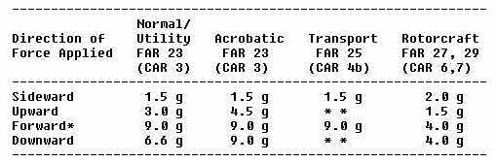
* When equipment mounting is located externally to one side, or forward of occupants, a forward load factor of 2.0 g is sufficient.
** Due to differences among various aircraft designs in flight and ground load factors, contact the aircraft manufacturer for the load factors required for a given model and location. In lieu of specific information, the factors used for FAR 23 utility category are acceptable for aircraft with never exceed speed of 250 knots or less and the factors used for FAR 23 acrobatic category for all other transport aircraft.
The following is an example of determining the static test loads for a 7 pound piece of equipment to be installed in a utility category aircraft (FAR Part 23).
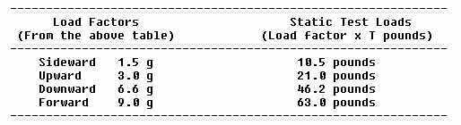
When an additional load is to be added to structure already supporting previously installed equipment, determine the capability of the structure to support the total load (previous load plus added load).
3. STATIC TESTS.
Caution: The aircraft and/or equipment can be damaged in applying static loads, particularly if careless or improper procedure is used.
It is recommended, whenever practicable, that static testing be conducted on a duplicate installation in a jig or mockup which simulates the related aircraft structure. Static test loads may exceed the yield limits of the assemblies being substantiated and can result in partially sheared fasteners, elongated holes, or other damage which may not be visible unless the structure is disassembled. If the structure is materially weakened during testing, it may fail at a later date. Riveted sheet metal and composite laminate construction methods especially do not lend themselves to easy detection of such damage. To conduct static tests:
a. Determine the weight and center of gravity position of the equipment item.
b. Make actual or simulated installation of attachment in the aircraft or preferably on a jig using the applicable static test load factors.
c. Determine the critical ultimate load factors for the up, down, side, fore, and aft directions. A hypothetical example which follows steps (1) through (4) below is shown in figure 1.1.
(1) Convert the gust, maneuvering, and ground load factors obtained from the manufacturer or FAA engineering to ultimate load factors. Unless otherwise specified in the airworthiness standards applicable to the aircraft, ultimate load factors are limit load factors multiplied by a 1.5 safety factor. (See columns 1, 2, and 3 for items A. B, and C of figure 1.1.)
(2) Determine the ultimate inertia load forces for the emergency landing conditions as prescribed in the applicable airworthiness standards. (See items D and E, column 3. of figure 1.1..)
(3) Determine what additional load factors are applicable to the specific seat, litter, berth, or cargo tiedown device installation. The ultimate load factors are then multiplied by these factors to obtain the static test factors. (To simplify this example, only the seat, litter, berth, and safety belt attachment factor of 1.33 was assumed to be applicable. See Item E, column 4, of figure 1.1.)
(4) Select the highest static test load factors obtained in Steps 1, 2, and/or 3 for each direction (up, down, side, fore, and aft). These factors are the critical static test load factors used to compute the static test load. (See column 6 of figure 1.1.)
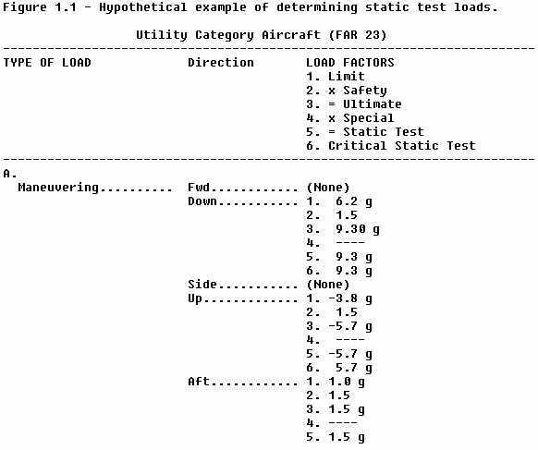
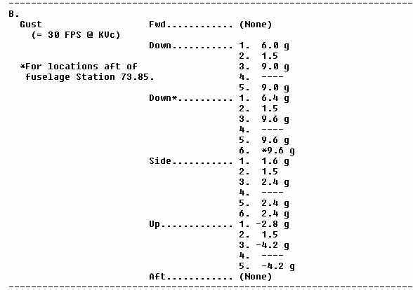
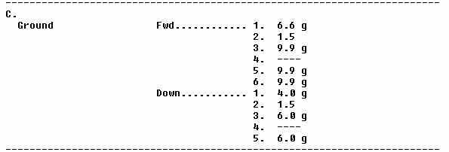
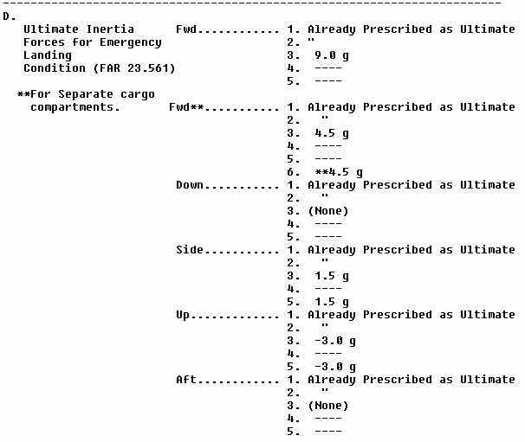
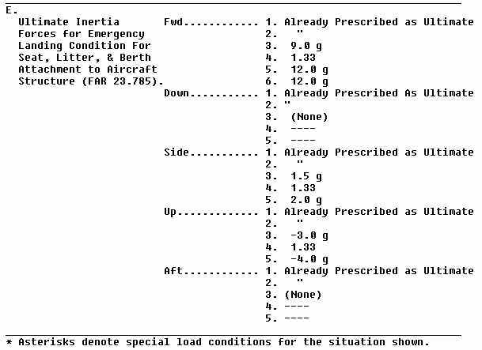
d. Apply load at center of gravity position (of equipment item or dummy) by any suitable means that will demonstrate that the attachment and structure are capable of supporting the required loads.
When no damage or permanent deformation occurs after 3 seconds of applied static load, the structure and attachments are acceptable. Should permanent deformation occur after 3 seconds, repair or replace the deformed structure to return it to its normal configuration and strength. Additional load testing is not necessary.
4. MATERIALS.
Use materials conforming to an accepted standard such as AN, NAS, TSO, or MIL-SPEC.
5. FABRICATION.
When a fabrication process which requires close control is used, employ methods which produce consistently sound structure that is compatible with the aircraft structure.
6. FASTENERS.
Use hardware conforming to an accepted standard such as AN, NAS, TSO, or MIL-SPEC. Attach equipment so as to prevent loosening in service due to vibration.
7. PROTECTION AGAINST DETERIORATION.
Provide protection against deterioration or loss of strength due to corrosion, abrasion, electrolytic action, or other causes.
8. PROVISIONS FOR INSPECTION.
Provide adequate provisions to permit close examination of equipment or parts of the aircraft that regularly require inspection, adjustment, lubrication, etc.
9. EFFECTS ON WEIGHT AND BALANCE.
Assure that the altered aircraft can be operated within the weight and center of gravity ranges listed in the FAA Type Certificate (TC) Data Sheet or Aircraft Listing. Determine that the altered aircraft will not exceed maximum gross weight. (If applicable, correct the loading schedule to reflect the current loading procedure. Consult Advisory Circular 43.13-1A, “Acceptable Methods, Techniques, and Practices – Aircraft, Inspection and Repair” for Weight and Balance Computation Procedures.
10. EFFECTS ON SAFE OPERATION.
Install equipment in a manner that will not interfere with or adversely affect the safe operation of the aircraft (controls, navigation equipment operation, etc.).
11. CONTROLS AND INDICATORS.
Locate and identify equipment controls and indicators so they can be operated and read from the appropriate crewmember position.
12. PLACARDING.
Label equipment requiring identification and, if necessary, placard operational instructions. Amend weight and balance information as required.
13. – 20. [RESERVED]
Wings
The wings are airfoils attached to each side of the fuselage and are the main lifting surfaces which support the airplane in flight. There are numerous wing designs, sizes, and shapes used by the various manufacturers. Each fulfill a certain need with respect to performance expected for the particular airplane. How the wing produces lift is explained in subsequent chapters.
Wings are of two main types – cantilever and semicantilever (Fig. 2-3). The cantilever wing requires no external bracing; the stress is carried by internal wing spars, ribs, and stringers. Generally, in this type wing the “skin” or metal wing covering is constructed to carry much of the wing stresses. Airplanes with wings so stressed are called stressed skin types. Treated aluminum alloy is most commonly used as the wing covering (Fig. 2-4). The semicantilever wing is braced both externally by means of wing struts attached to the fuselage, and internally by spars and ribs.
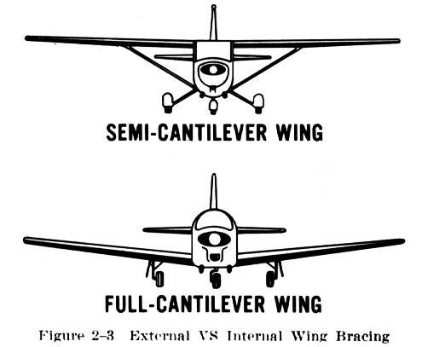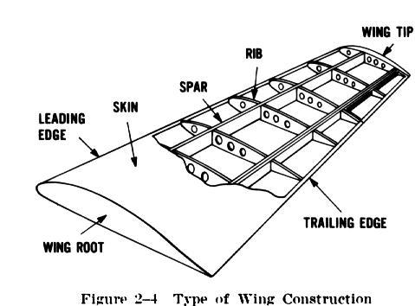
The principal structural parts of the wing are spars, ribs, and stringers. These are reinforced by trusses, I beams, tubing, or other appropriate devices. The wing ribs actually determine the shape and thickness of the wing (airfoil). In most modern airplanes, the fuel tanks are either an integral pat of the wing’s structure, or consist of flexible containers mounted inside of the wing structure.
Load Factors in Airplane Design:
The answer to the question “how strong should an airplane be” is determined largely by the use to which the airplane will be subjected. This is a difficult problem, because the maximum possible loads are much too high for use in efficient design. It is true that any pilot can make a very hard landing or an extremely sharp pullup from a dive which would result in abnormal loads. However, such extremely abnormal loads must be dismissed somewhat if we are to build airplanes that will take off quickly, land slowly, and carry a worthwhile payload.
The problem of load factors in airplane design then reduces to that of determining the highest load factors which can be expected in normal operation under various operational situations. These load factors are called “limit load factors.” For reasons of safety, it is required that the airplane be designed to withstand these load factors without any structural damage. Although Federal Aviation Regulations require that the airplane structure be capable of supporting one and one-half times these limit load factors without failure, it is accepted that parts of the airplane may bend or twist under these loads and that some structural damage may occur.
This 1.5 value is called the “factor of safety” and provides, to some extent, for loads higher than those expected under normal and reasonable operation. However, this strength reserve is not something which pilots should willfully abuse; rather it is there for their protection when they encounter unexpected conditions.
The above considerations apply to all loading conditions, whether they be due to gusts, maneuvers, or landings. The gust load factor requirements now in effect are substantially the same as those which have been in existence for years. Hundreds of thousands of operational hours have proven them adequate for safety. Since the pilot has little control over gust load factors (except to reduce the airplane’s speed when rough air is encountered), the gust loading requirements are substantially the same for most general aviation type airplanes regardless of their operational use. Generally speaking, the gust load factors control the design of airplanes which are intended for strictly nonacrobatic usage.
An entirely different situation exists in airplane design with maneuvering load factors. It is necessary to discuss this matter separately with respect to: (1) Airplanes which are designed in accordance with the Category System (i.e., Normal, Utility, Acrobatic); and (2) Airplanes of older design which were built to requirements which did not provide for operational categories.
Airplanes designed under the Category System are readily identified by a placard in the cockpit which states the operational category (or categories) in which the airplane is certificated. The maximum safe load factors (limit load factors) specified for airplanes in the various categories are as follows:
CATEGORY LIMIT LOAD
Normal [1] ————————————- 3.8 -1.52
Utility (mild acrobatics, including spins) —– 4.4 -1.76
Acrobatic ————————————– 6.0 -3.0
[1] For airplanes with gross weight of more than 4,000 pounds, the limit load factor is reduced.
To the limit loads given above a safety factor of 50 percent is added.
There is an upward graduation in load factor with the increasing severity of maneuvers. The Category System provides for obtaining the maximum utility of an airplane. If normal operation alone is intended, the required load factor (and consequently the weight of the airplane) is less than if the airplane is to be employed in training or acrobatic maneuvers as they result in higher maneuvering loads.
Airplanes which do not have the category placard are designs which were constructed under earlier engineering requirements in which no operational restrictions were specifically given to the pilots. For airplanes of this type (up to weights of about 4,000 pounds) the required strength is comparable to present day utility category airplanes, and the same types of operation are permissible. For airplanes of this type over 4,000 pounds, the load factors decrease with weight so that these airplanes should be regarded as being comparable to the normal category airplanes designed under the Category System, and they should be operated accordingly.

